Food in the nursery
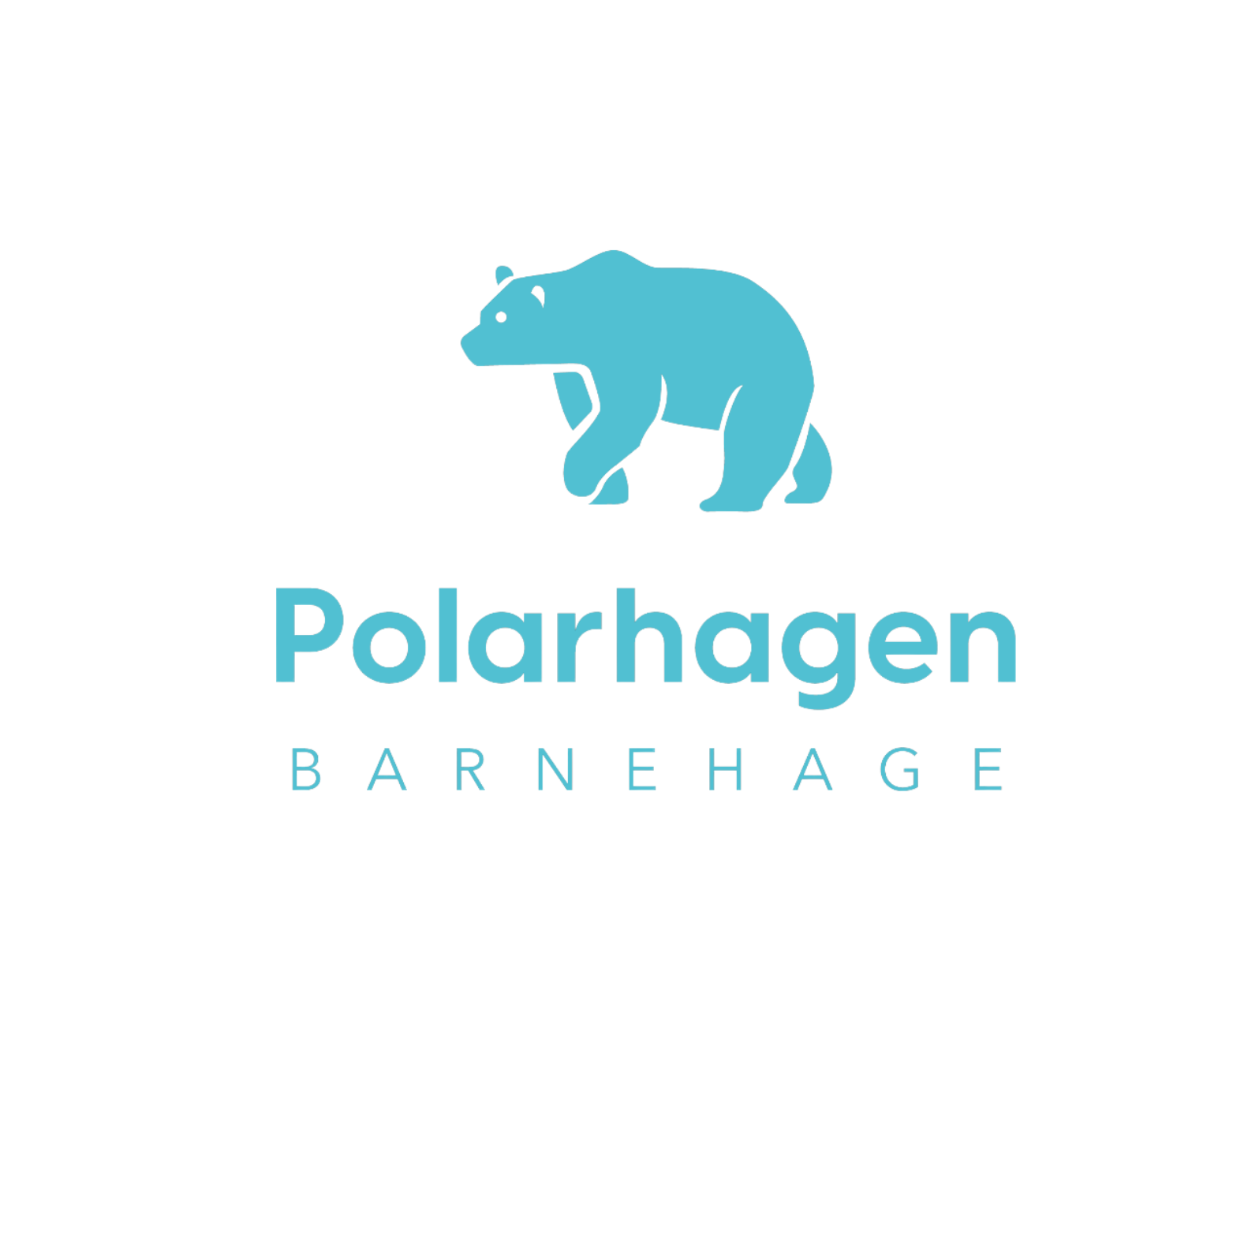
According to the Kindergarten-law, children have the right to participate in their food and eating. This means that the children are involved in the planning of food and meal activities. They help to cook, cover and tidy up after meals. The little ones are involved in making their own choices and practicing self-regulation.
Meals in kindergarten is an important learning arena. The adults participate during meals with good conversations and by eating with the children. We have breakfast, lunch and fruit in the kindergarten. We have 3 hot food meals for lunch Monday, Wednesday and Friday.
For breakfast, we mostly serve bread but we sometimes have oatmeal with yoghurt/biola or the occasional waffles.
If your child have any food allergies, we will prepare their own meal with food they can eat. If your child does not eat pork, we have several other options, such as food made from chicken and turkey
Our focus is:
• learn about the connection between food, body and health
• gain knowledge of the name, origin and use of foods
• butter their own slice of bread. It can promote both learning and mastery
• that children participate in table setting and cleaning up after the meal
• utilize sensory experiences related to food; taste, smell, see (colors, shapes), feel (heaviness, surface, consistency) and hear (crunch, slurp)
• get to know hunger, thirst and satiety
• use meals and cooking for linguistic development and curiosity related to the food and meal
• gain knowledge of mathematical relations through cooking, including the use of counting, sorting, weighing and measuring
We have a varied diet. bake our own bread, and we make a lot of the food from scratch with the children. We have «kitchen guards» who participate in table setting and cleaning up after meals.
We follow the guidelines of the Norwegian Directorate of Health.

