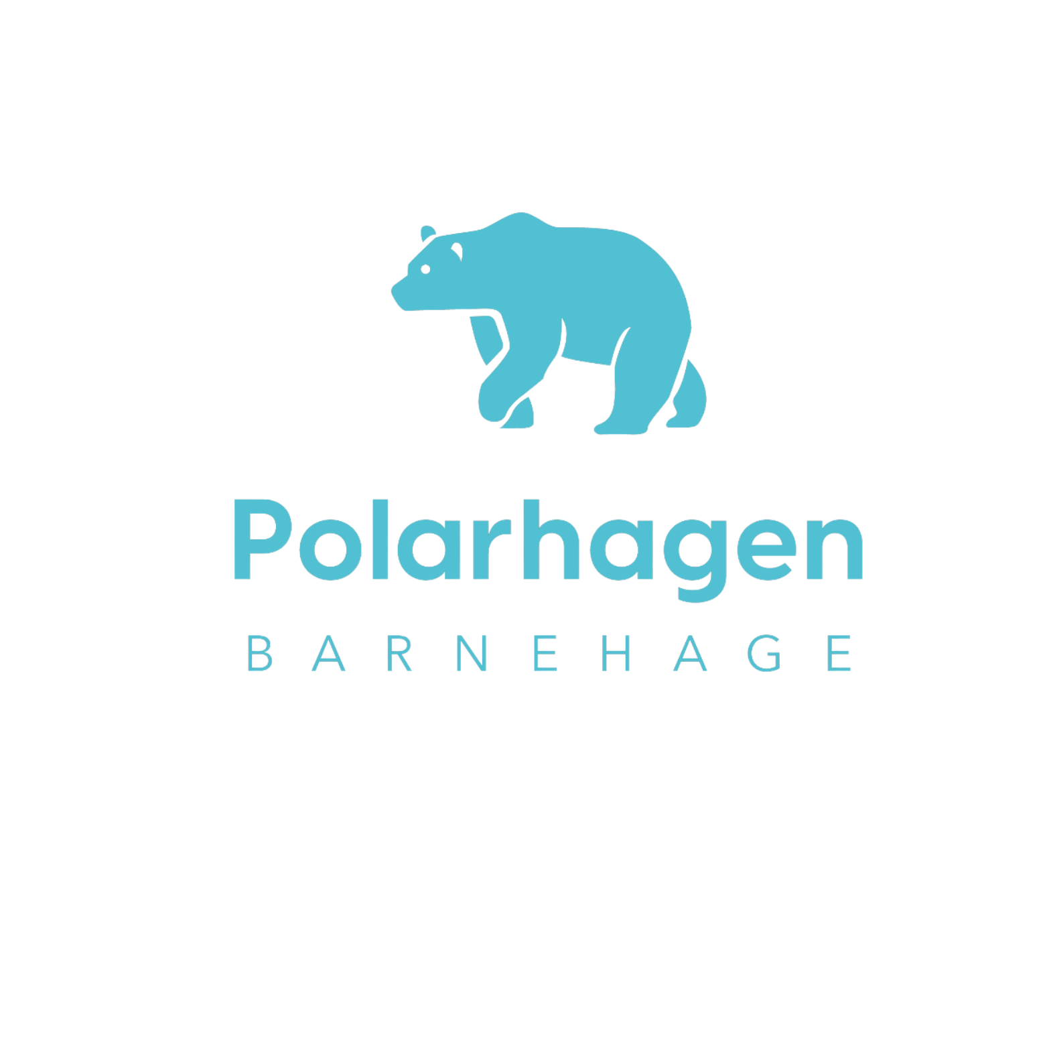
Bylaws approved by the Board 17.11.2025

Innhold
§ 1 Company Name 1
§ 2 Premises 1
§ 3 Share Capital 2
§ 4 Purpose of the Company 2
§ 5 Play and Activity Areas 2
§ 6 Admission Authority 3
Admission criteria (priority order): 3
§ 7 Notice Period 4
§ 8 Health Regulations 4
§ 9 Opening Hours, Planning Days, and Holidays 4
§ 10 Parent / Guardian Payment 5
§ 11 The Board 5
§ 12 Internal Control 5
§ 13 The Kindergarten’s Coordinating Committee (SU) 6
§ 14 Parents’ Council 6
§ 15 Amendments to the Bylaws 7
§ 16 7

§ 1 Company Name
The name of the company is Polarhagen Barnehage AS. The kindergarten is privately owned and operated by Polar-Holding AS.

§ 2 Premises
The company’s premises are located at Ørneveien 7, 9015 Tromsø, Tromsø Municipality.

§ 3 Share Capital
The company’s share capital is NOK 60,000, divided into 3,000 ordinary shares, each with a nominal value of NOK 20.

§ 4 Purpose of the Company
The purpose of the company is to operate a kindergarten for preschool-aged children. The kindergarten’s operations shall at all times comply with Section 2 of the Norwegian Kindergarten Act.
- The kindergarten shall function as an educational institution.
- It shall provide opportunities for play, development, and meaningful experiences.
- It shall consider children’s age, functional level, gender, social, ethnic, and cultural background, including Sami language and culture.
- It shall convey values, support children’s cultural expression, and contribute to joy and mastery.
- It shall support curiosity, creativity, and knowledge development.
- It shall promote health, prevent difficulties, and reduce social inequality.
- The Ministry establishes the Framework Plan and regulations.
- The owner may adapt the plan locally.
- Based on the Framework Plan, the Coordinating Committee establishes the annual pedagogical plan.
The provision in §1 regarding Christian values does not apply to Polarhagen Barnehage.

§ 5 Play and Activity Areas
Polarhagen Barnehage AS is approved under §10 of the Kindergarten Act.
Conditions:
- Municipal regulations on space use must be followed.
- 4 m² net play/activity area for children over 3 years.
- 5 m² net play/activity area for children under 3 years.
This corresponds to 44 children if all are over 3.

§ 6 Admission Authority
- Deadlines for main and transfer admissions are announced yearly in local newspapers and on the municipality’s website.
- Applications are submitted through the parent portal.
- Documentation is sent to the municipality’s admissions office.
- The kindergarten year runs from 01.08–31.07.
- Children retain their place until 31.07. of the year they turn six.
- The general manager may offer placement outside coordinated admissions.
- Decisions are made through the parent portal process.
- Polarhagen follows the municipality’s coordinated admissions.
- The general manager conducts admissions in consultation with staff.

Admission criteria (priority order):
1. Children with disabilities (expert assessment).
2. Siblings.
3. Children of permanent staff.
4. Children listing Polarhagen as first choice.
5. Children whose parents have ties to the kindergarten.
6. Group composition (age and gender distribution).
7. Lottery if otherwise equal.

§ 7 Notice Period
- Notice period is two months from the day written notice is received.
- Notices submitted 1 April–31 May run until July.
- Payment is reduced if a new child fills the place.
- Termination by the kindergarten requires valid grounds.
- Repeated breaches may lead to immediate termination.

§ 8 Health Regulations
- A health declaration must be submitted before the child starts.
- Sick children must not attend; the pedagogical leader decides when in doubt.
- Suspected epidemics or health hazards: general manager may contact a doctor and inform guardians.
- Medication requires official forms and routines.
- Allergies must be documented by a doctor.
- All children are insured 24/7 via Gjensidige through PBL.

§ 9 Opening Hours, Planning Days, and Holidays
- Open 07:00–16:30.
- Children must take 4 weeks of vacation; 3 during summer closure (weeks 28–30).
- Remaining week can be taken Sept–April.
- Kindergarten may close when fewer than 8 children attend (Christmas, Easter, industrial holiday).
- Wednesday before Easter: open 07:00–12:30.
- Reduced hours in holidays if all parents are consulted.
- 5 planning days per year.
- Children starting after 1 May follow bylaws’ vacation rules.
- Late pickup: guardians must sign; fee of NOK 500 after third occurrence.

§ 10 Parent / Guardian Payment
Parent payment covers 11 months, with July free of charge.
The kindergarten follows the municipal and national maximum price regulations.
- Payment is made monthly based on issued invoices. Guardians must inform the kindergarten if an invoice is not received. Both guardians may be held financially responsible when they share custody, regardless of whose name appears on the invoice.
- Sibling discounts follow Tromsø Municipality’s rates.
- All guardians with a kindergarten placement must pay for 11 months per year.
- Failure to pay may result in debt collection procedures. Significant non-payment may result in termination of the placement, after which a new application for placement must be submitted.
- Polarhagen Barnehage charges food fees. These may be adjusted in line with general food price inflation. The Coordinating Committee determines the extent of meal services. Food fees follow a self-cost principle and may be adjusted with two months’ notice.
- Food fees cover all daily meals.
- For absences longer than one month, guardians may apply for a reduction in food fees. Long-term absence must be notified at least one month in advance.
- If the kindergarten is closed for more than two full days due to unforeseen circumstances (e.g., staffing shortages, power outages, water disruptions), parents are exempt from payment starting from the first full day of closure.

§ 11 The Board
The company’s board consists of two members: the owner of the shares in Polar-Holding AS and one additional member.

§ 12 Internal Control
- Health, Safety and Environment (HSE) is ensured through internal control routines prepared by the Private Kindergartens Association (PBL) and shall be carried out regularly by the kindergarten’s management and staff.
- The kindergarten’s documentation for internal control is stored digitally in PBL Mentor and is continuously updated.

§ 13 The Kindergarten’s Coordinating Committee (SU)
The kindergarten’s Coordinating Committee (SU) shall consist of an equal number of representatives from the parents and the staff. Two representatives from the parents, preferably one from each department, and two representatives from the staff, one of whom may be the general manager and one a pedagogical leader.
- The general manager has the right to attend, speak, and propose matters in the SU.
- The SU shall operate in accordance with the Kindergarten Act and relevant regulations, as well as municipal guidelines and decisions.
- The SU shall address matters and has the right to express its opinion on issues of importance to the content of the kindergarten.
- The SU has the right to provide input if the kindergarten applies for an exemption from the staffing norm for pedagogical personnel. The SU’s statement must be attached to the owner’s application.
- The SU primarily has an advisory role, except that it adopts the annual plan.
- The SU also participates in planning and carrying out events for parents.
- The SU constitutes itself and elects its own leader. Decisions or advisory statements of the SU are determined by majority vote. In the event of a tie, the leader’s vote decides. If the leader is absent, the meeting chair’s vote decides.
- Meetings of the SU are held according to a schedule set by the SU, and additionally whenever the SU or the kindergarten deems it necessary.
- A separate protocol is kept for the SU, containing the advice and statements issued. The protocol must show the time and place of the meetings, voting distribution, and any required dissent. SU members sign the protocol. The protocol is accessible only to SU members, the general manager, and individuals granted access by the SU.
- Matters concerning employee working conditions, admission of children, and similar topics shall not be handled by the SU.

§ 14 Parents’ Council
The Parents’ Council shall promote the common interests of the parents and contribute to cooperation between the kindergarten and parents to create a positive kindergarten environment.
- The Parents’ Council consists of the parents/guardians of all children in the kindergarten.
- The Parents’ Council elects two representatives to the SU.
- The Parents’ Council shall be presented with, and has the right to express an opinion on, matters of importance to parents’ relationship with the kindergarten.
- The general manager is responsible for calling the first Parents’ Council meeting of the kindergarten year.
- The Parents’ Council meets once a year. At Polarhagen Barnehage, this takes place at the beginning of each kindergarten year.
- At voting, each child is granted one vote, and decisions are made by simple majority.
A separate record is kept for the Parents’ Council, documenting the advisory statements made. The record must show the time and place of the meeting, voting distribution, and any required dissent. The Parents’ Council’s secretary signs the record. The record is accessible only to members of the Parents’ Council, the board, the general manager, and individuals granted access by the Parents’ Council.

§ 15 Amendments to the Bylaws
The general manager of Polarhagen Barnehage AS may make amendments to the bylaws together with the board of Polarhagen Barnehage.
Such amendments must be announced in writing with a notice period of at least two months before implementation.
See also the agreement on the allocation of kindergarten placement regarding changes in terms.

§ 16
The owner may sell the kindergarten for use in similar activities.

